External Document

Assignment 1

COMP308

By: Jonathan Lee #822937603

Wireframes

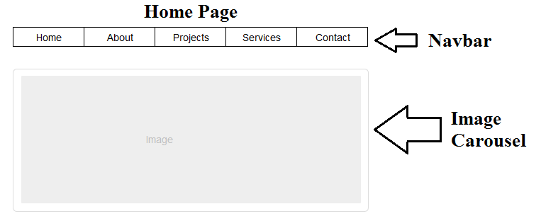

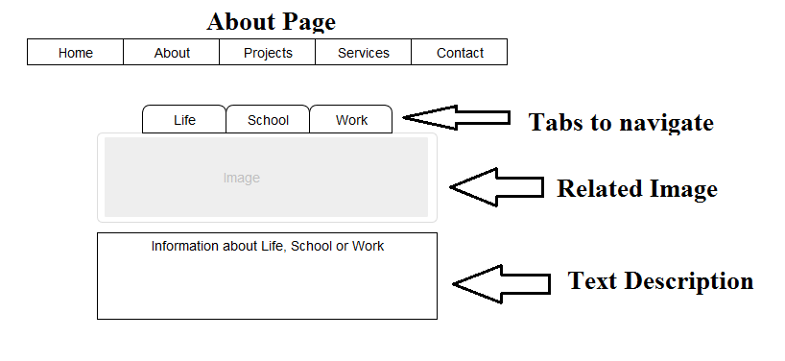

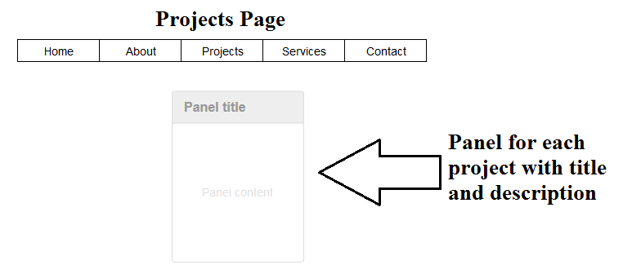

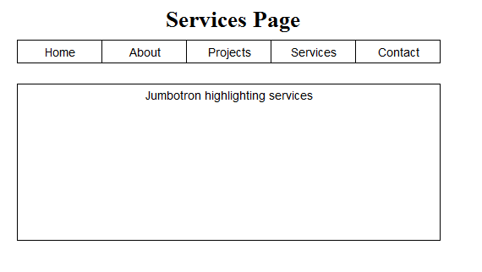

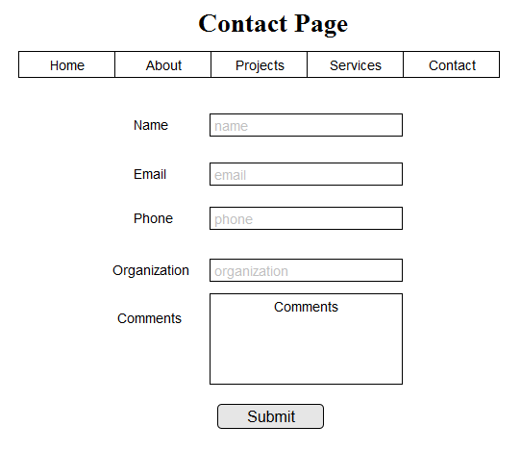

Technologies Used

Node.js/Nodemon – Server utility, nodemon will actively look for changes in code so that the server is always up to date with the latest changes.

Express – Framework that the development structure is based on with routes and views to implement on development.

Bootstrap – HTML and CSS framework to create cool pages.

Font Awesome – Set of epic icons for even cooler pages.

Style Guide

The Navbar and general background utilizes a dim grey colour.

The navbar and selected tabs highlights to a blue colour #154A8A.

The tabs selected background is a yellow #FCD900.

The tabs selected text is green.

Projects Panels use panel primary, success, and danger respectively.